Odoo – Vendor Price Lists

# Overview

Vendor price lists provide a way to track multiple costs on products depending on vendors. Each product can contain entries for multiple vendors with their related price.

# Creating a Vendor Price

To set a vendor price on a product;

* Within the **Purchase** App, open the **Product** that needs the vendor price added.
* Go to the **Purchase** tab.
* The list of Vendor prices is shown. Either update an already created vendor price or click **Add an item** to create a new one.

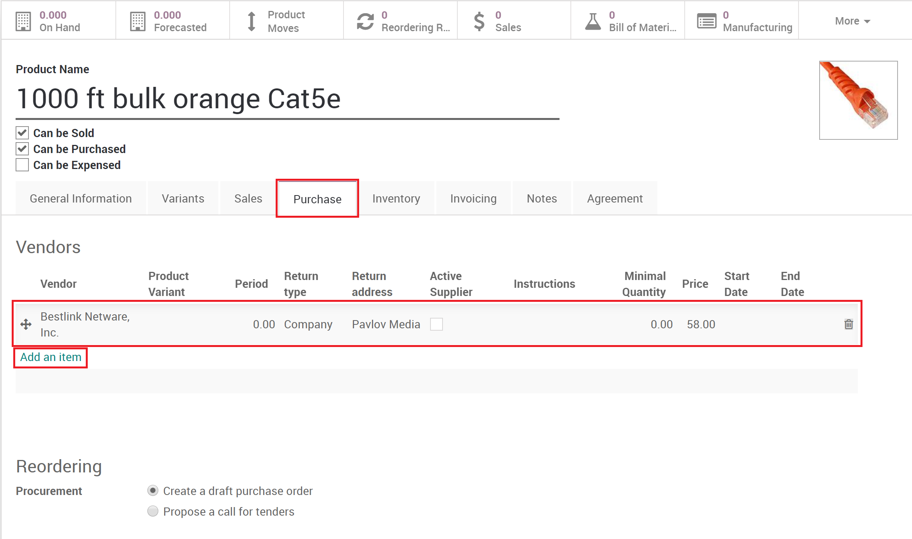

* When creating a new vendor price, fill in the required fields

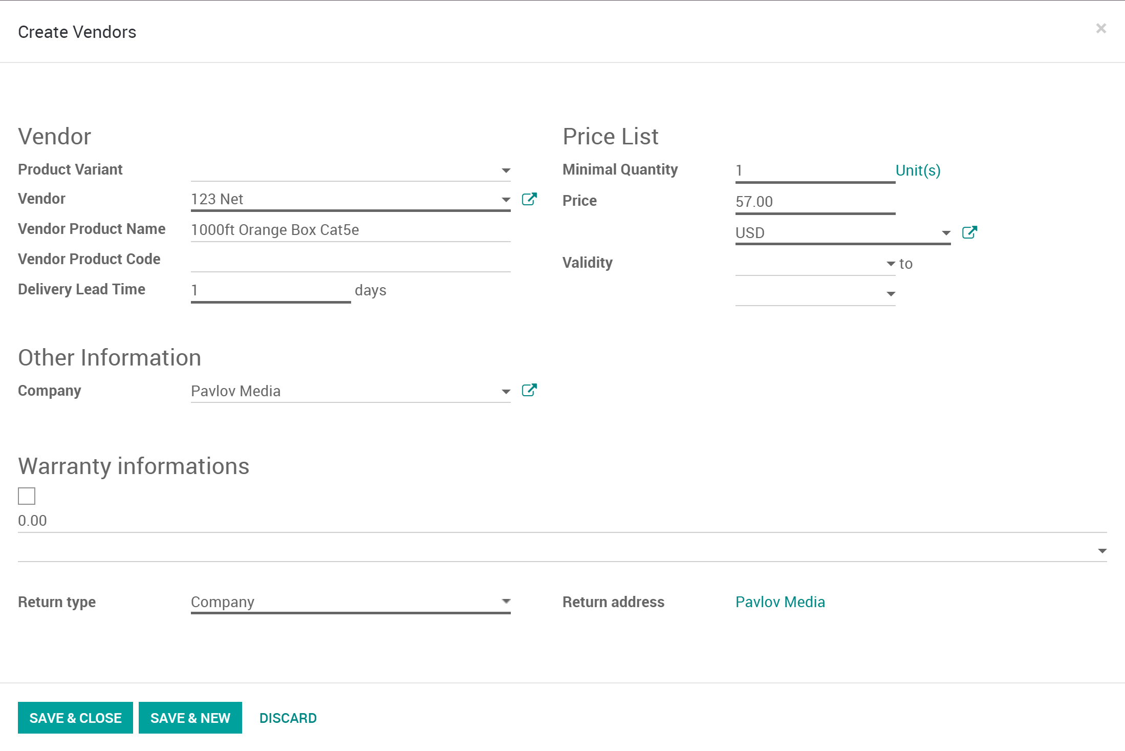

Field Descriptions:

* + - **Product Variant**: The product or product variant that this price will be linked to.
    - **Vendor**: The vendor that will have this product and price.
    - **Vendor Product Name**: If the vendor has its own name for their product it can be tracked here.
    - **Vendor Product Code**: If the vendor has its own product code it can be tracked here.
    - **Delivery Lead Time**: The typical time it takes to receive the product after being ordered from this vendor.
    - **Minimum Quantity**: The minimum quantity the vendor requires in order to purchase the product.
    - **Price**: The price the vendor is selling the product for.
    - **Validity**: The dates that this price is valid for.
    - **Company**: What company this vendor price belongs to. (Odoo multi-company configuration)
    - **Warranty**: Warranty period in months for the relationship between company and vendor. (Not warranty between company and customers)
    - **Return Type**: Where will products be returned to.
    - **Return Address**: What address will returns be sent to.
* Click **Save & Close** or **Save & New**

**IMPORTANT**: The order of vendors in the list matter. The top vendor is the default vendor to be used in automatic re-ordering rules when used on the product.